Yohanes Dimas Pratama

A11.2021.13254 - A11.43UG2

Aplikasi Biodata

Hasil:

* 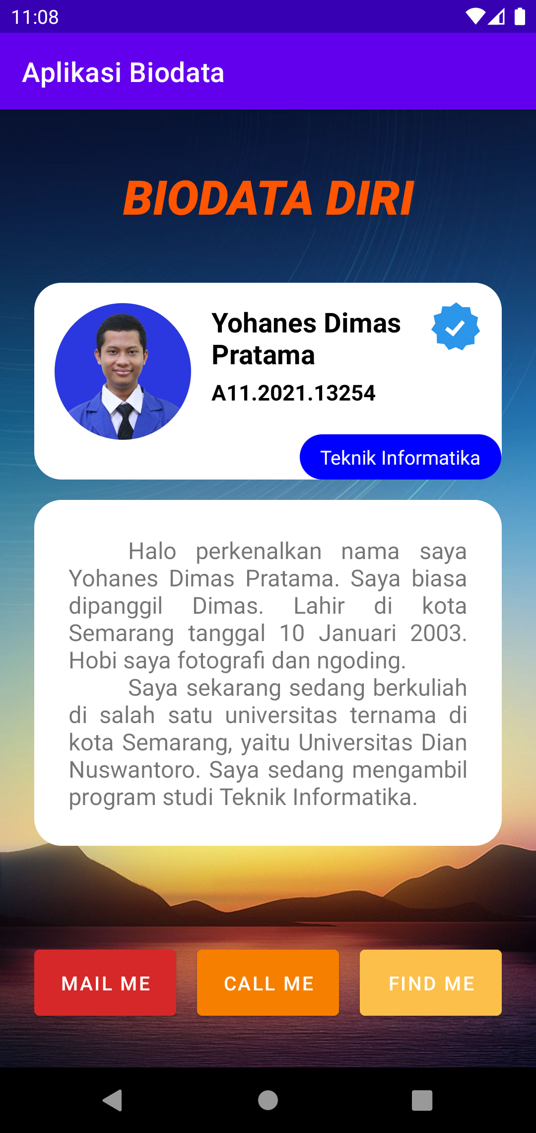

Halaman utama aplikasi

* 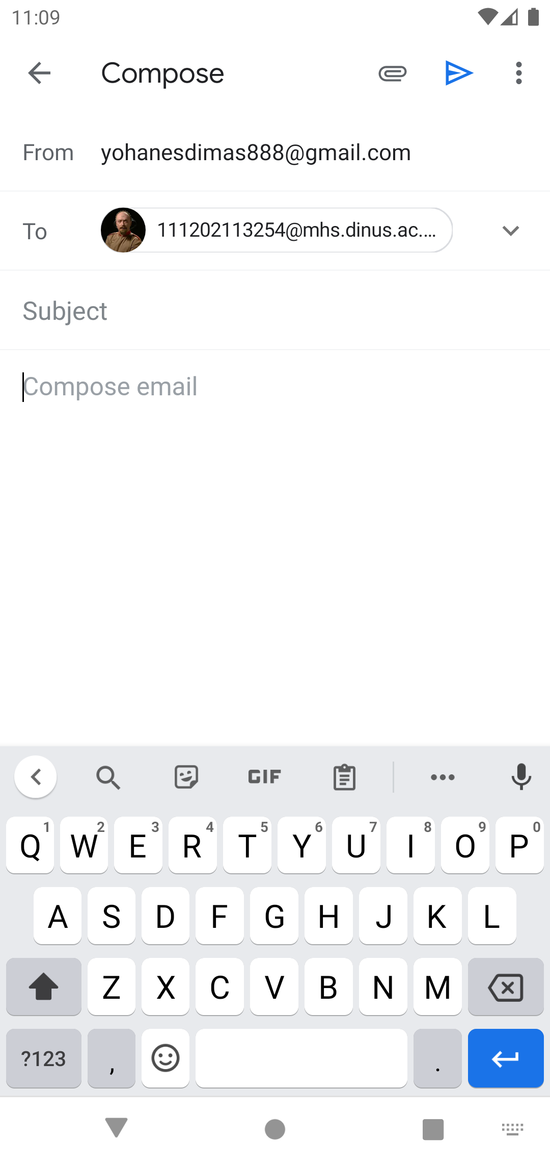

Saat klik tombol “Mail Me”

* 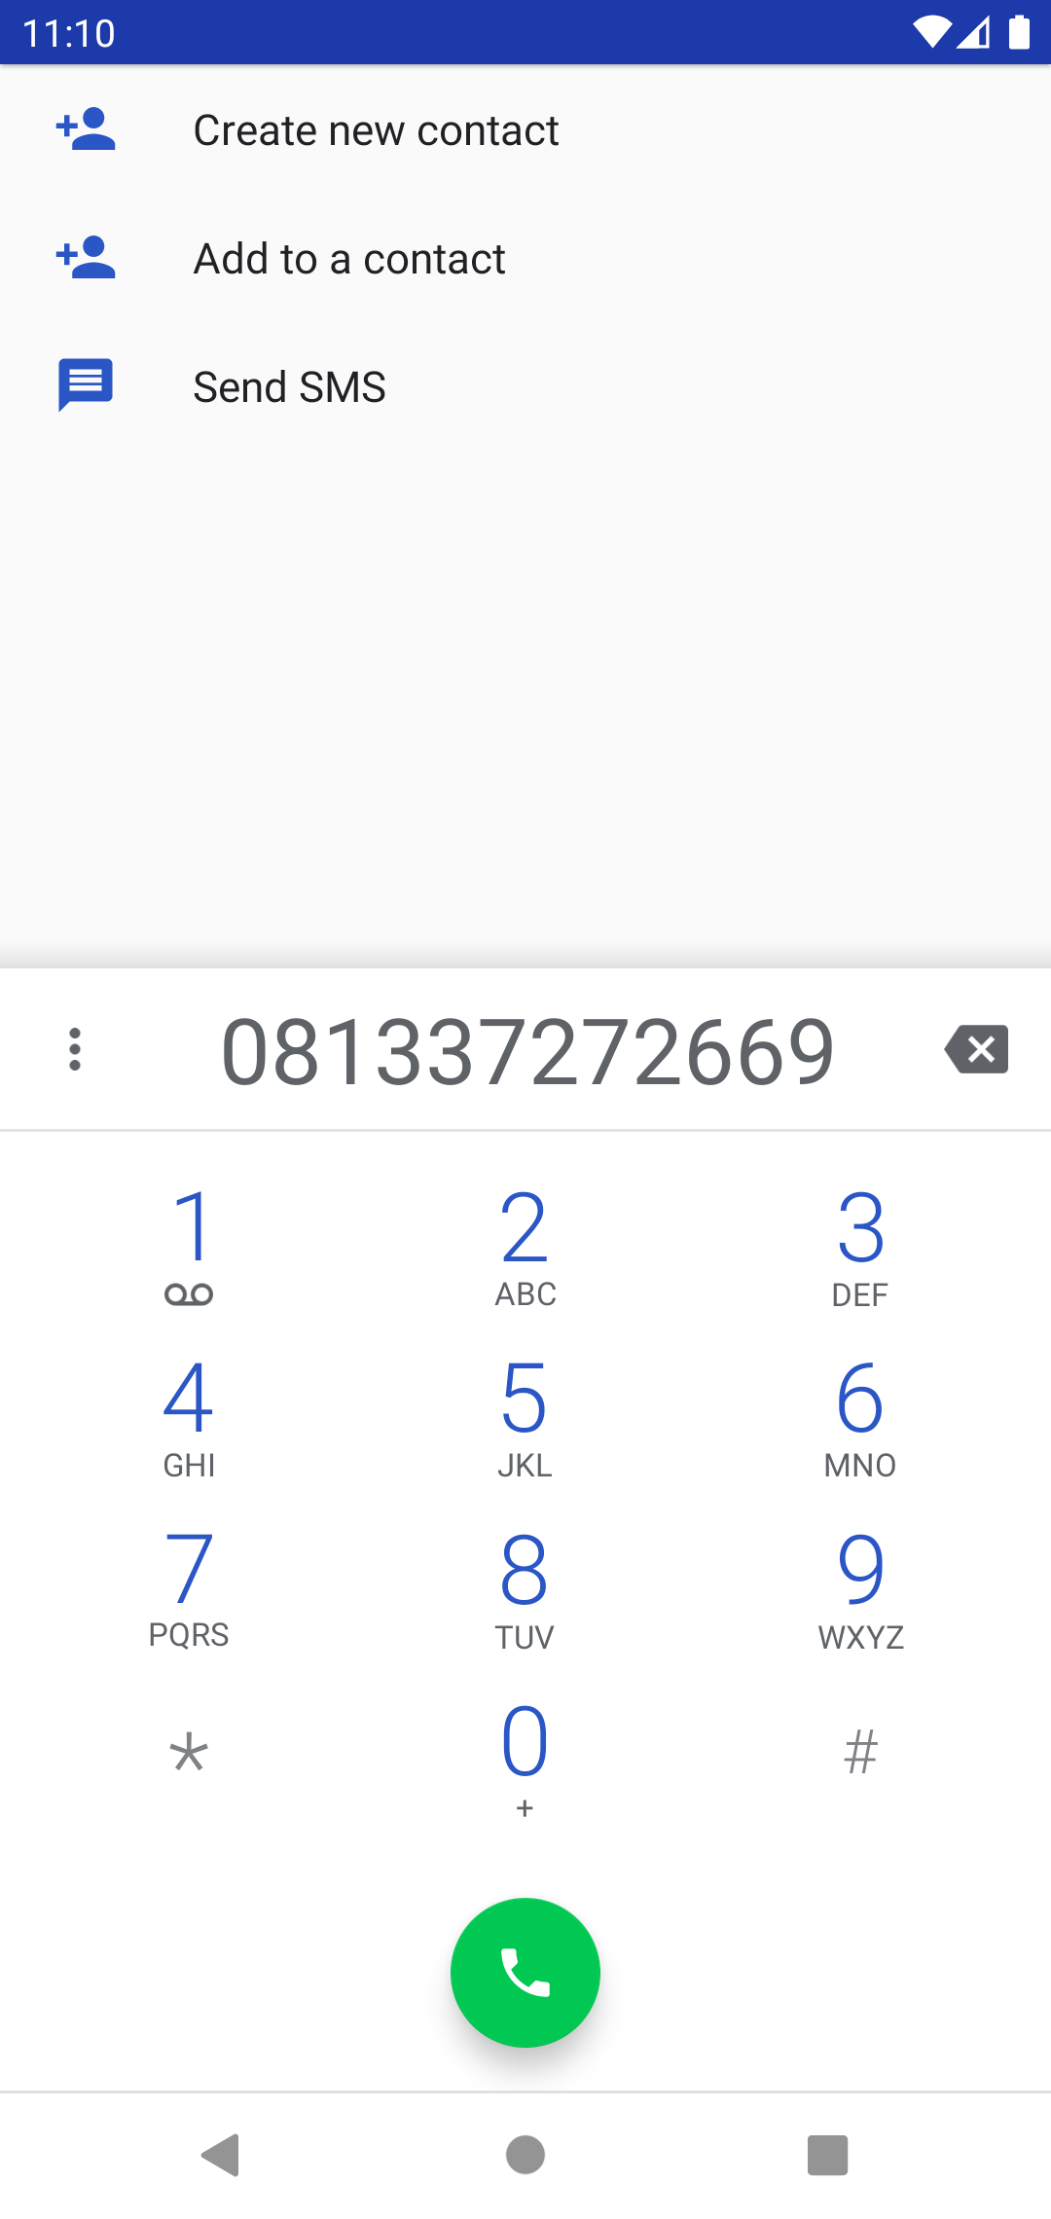

Saat klik tombol “Mail Me”

* 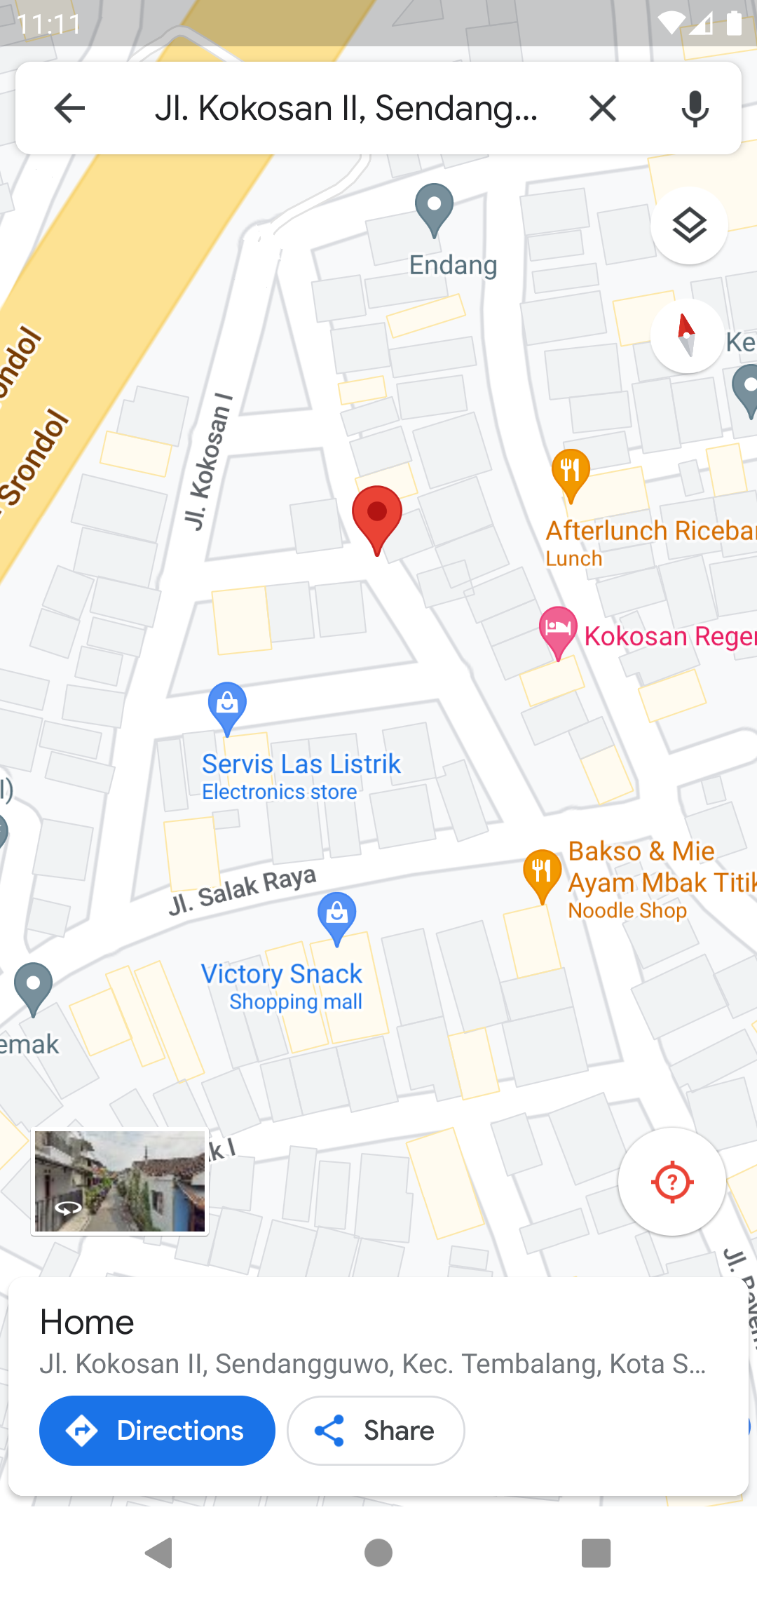

Saat klik tombol “Find Me”

Link GitHub:

<https://github.com/weztcy/Aplikasi-Biodata-Java>

Coding:

* activity_main.xml

<?xml version="1.0" encoding="utf-8"?>  
<LinearLayout xmlns:android="http://schemas.android.com/apk/res/android"  
 xmlns:app="http://schemas.android.com/apk/res-auto"  
 xmlns:tools="http://schemas.android.com/tools"  
 android:layout_width="match_parent"  
 android:layout_height="match_parent"  
 tools:context=".MainActivity"  
 android:orientation="vertical"  
 android:padding="20dp"  
 android:background="@drawable/naturebg">  
 <TextView  
 android:layout_width="match_parent"  
 android:layout_height="wrap_content"  
 android:layout_marginTop="20dp"  
 android:textAlignment="center"  
 android:text="BIODATA DIRI"  
 android:textSize="35dp"  
 android:fontFamily="sans-serif-black"  
 android:textStyle="italic"  
 android:textColor="#ff5500"/>  
 <LinearLayout  
 android:layout_width="match_parent"  
 android:layout_height="144dp"  
 android:orientation="horizontal"  
 android:padding="15dp"  
 android:layout_marginTop="40dp"  
 android:layout_marginLeft="5dp"  
 android:layout_marginRight="5dp"  
 android:background="@drawable/rounded_shape">  
 <de.hdodenhof.circleimageview.CircleImageView  
 android:layout_width="100dp"  
 android:layout_height="100dp"  
 android:layout_weight="0"  
 android:src="@drawable/fotomhs">  
 </de.hdodenhof.circleimageview.CircleImageView>  
 <LinearLayout  
 android:layout_width="200dp"  
 android:layout_height="wrap_content"  
 android:layout_weight="0"  
 android:orientation="vertical"  
 android:layout_marginStart="15dp">  
 <TextView  
 android:layout_width="wrap_content"  
 android:layout_height="wrap_content"  
 android:text="Yohanes Dimas Pratama"  
 android:textSize="20dp"  
 android:textStyle="bold"  
 android:textColor="@color/black"/>  
 <TextView  
 android:layout_width="wrap_content"  
 android:layout_height="wrap_content"  
 android:layout_marginTop="4dp"  
 android:text="A11.2021.13254"  
 android:textSize="16dp"  
 android:textStyle="bold"  
 android:textColor="@color/black"/>  
 </LinearLayout>  
 </LinearLayout>  
 <ImageView  
 android:layout_width="40dp"  
 android:layout_height="40dp"  
 android:src="@drawable/verified"  
 android:layout_marginTop="-362px"  
 android:layout_marginLeft="808px"  
 android:layout_marginBottom="362px"/>  
 <TextView  
 android:layout_width="wrap_content"  
 android:layout_height="wrap_content"  
 android:text="Teknik Informatika"  
 android:textColor="@color/white"  
 android:background="@drawable/rounded_shape2"  
 android:paddingTop="7dp"  
 android:paddingBottom="7dp"  
 android:paddingLeft="15dp"  
 android:paddingRight="15dp"  
 android:layout_marginLeft="549px"  
 android:layout_marginTop="-201px"/>  
 <TextView  
 android:layout_width="wrap_content"  
 android:layout_height="wrap_content"  
 android:layout_marginTop="15dp"  
 android:layout_marginLeft="5dp"  
 android:layout_marginRight="5dp"  
 android:padding="25dp"  
 android:background="@drawable/rounded_shape"  
 android:textSize="17dp"  
 android:justificationMode="inter_word"  
 android:text="\t\t\t\t\t\tHalo perkenalkan nama saya Yohanes Dimas Pratama. Saya biasa dipanggil Dimas. Lahir di kota Semarang tanggal 10 Januari 2003. Hobi saya fotografi dan ngoding.\n\t\t\t\t\t\tSaya sekarang sedang berkuliah di salah satu universitas ternama di kota Semarang, yaitu Universitas Dian Nuswantoro. Saya sedang mengambil program studi Teknik Informatika.">  
 </TextView>  
 <LinearLayout  
 android:layout_width="match_parent"  
 android:layout_height="60dp"  
 android:layout_marginTop="70dp"  
 android:layout_marginLeft="5dp"  
 android:layout_marginRight="5dp">  
 <Button  
 android:id="@+id/button_email"  
 android:layout_width="match_parent"  
 android:layout_height="match_parent"  
 android:layout_weight="1"  
 android:layout_marginEnd="10dp"  
 android:text="mail me"  
 android:backgroundTint="#d62828"/>  
 <Button  
 android:id="@+id/button_call"  
 android:layout_width="match_parent"  
 android:layout_height="match_parent"  
 android:layout_weight="1"  
 android:layout_marginStart="5dp"  
 android:layout_marginEnd="5dp"  
 android:text="call me"  
 android:backgroundTint="#f77f00"/>  
 <Button  
 android:id="@+id/button_loc"  
 android:layout_width="match_parent"  
 android:layout_height="match_parent"  
 android:layout_weight="1"  
 android:layout_marginStart="10dp"  
 android:text="find me"  
 android:backgroundTint="#fcbf49"/>  
 </LinearLayout>  
</LinearLayout>

* MainActivity.java

package com.example.latihan1;  
  
import android.content.Intent;  
import android.net.Uri;  
import android.os.Bundle;  
import android.view.View;  
import android.widget.Button;  
  
import androidx.appcompat.app.AppCompatActivity;  
  
public class MainActivity extends AppCompatActivity {  
  
 Button button_call, button_email, button_loc;  
  
 @Override  
 protected void onCreate(Bundle savedInstanceState) {  
 super.onCreate(savedInstanceState);  
 setContentView(R.layout.*activity_main*);  
  
 button_call = findViewById(R.id.*button_call*);  
 button_email = findViewById(R.id.*button_email*);  
 button_loc = findViewById(R.id.*button_loc*);  
 String email = "111202113254@mhs.dinus.ac.id";  
  
 button_call.setOnClickListener(new View.OnClickListener() {  
 @Override  
 public void onClick(View view) {  
 String nomor = "081337272669";  
 Intent menelepon = new Intent(Intent.*ACTION_DIAL*);  
 menelepon.setData(Uri.*fromParts*("tel", nomor, null));  
 startActivity(menelepon);  
 }  
 });  
 button_email.setOnClickListener(new View.OnClickListener() {  
 @Override  
 public void onClick(View view) {  
 Intent mengemail = new Intent(Intent.*ACTION_VIEW* , Uri.*parse*("mailto:"+ email));  
 startActivity(mengemail);  
 }  
 });  
 button_loc.setOnClickListener(new View.OnClickListener() {  
 @Override  
 public void onClick(View view) {  
 Intent openMap = new Intent(Intent.*ACTION_VIEW* , Uri.*parse*("https://goo.gl/maps/hPZgRBoL2NYJWg8R7"));  
 startActivity(openMap);  
 }  
 });  
 }  
}

* rounded_shape.xml

<?xml version="1.0" encoding="utf-8"?>  
<shape android:shape="rectangle" xmlns:android="http://schemas.android.com/apk/res/android">  
 <solid android:color="@color/white"/>  
 <corners android:radius="20dp"/>  
</shape>

* rounded_shape2.xml

<?xml version="1.0" encoding="utf-8"?>  
<shape android:shape="rectangle" xmlns:android="http://schemas.android.com/apk/res/android">  
 <solid android:color="#0000ff"/>  
 <corners android:radius="20dp"/>  
</shape>